**IMMIGRATION AND INTEGRATION POLICIES TO BE REVISED TO CREATE EQUAL OPPORTUNITIES FOR IMMIGRANTS IN THE UNITED STATES**

By Josh, Pony, So, Ha

**INTRODUCTION**

Immigrants comprise about 14% of the total U.S population. Their presence and role in the U.S has become a topic of discussion in all media outlets, in classes, and even in social gatherings. In October 2017, the political administration implemented the Travel Ban policy that restricted nationals from 11 countries (10 being Muslim-majority) from entering and staying in the United States, with hopes to protect the country from domestic and international terrorism.

*“Numerous foreign-born individuals have been convicted or implicated in terrorism-related crimes since September 11, 2001, including foreign nationals who entered the United States after receiving visitor, student, or employment visas, or who entered through the United States refugee resettlement program. Deteriorating conditions in certain countries due to war, strife, disaster, and civil unrest increase the likelihood that terrorists will use any means possible to enter the United States. The United States must be vigilant during the visa-issuance process to ensure that those approved for admission do not intend to harm Americans and that they have no ties to terrorism”* (The White House, 2017)*[1].*

Stereotypes such as immigrants drive up crime rate, immigrants are poor, and immigrants take jobs from citizens, circulate throughout the media giving rise to prejudice against these clusters coming into the United States. This paper presents research on immigrants who come from 7 Muslim-majority travel ban countries (Iran, Iraq, Somalia, Libya, Yemen, Syria, Sudan[2]) and analyzes these negative stereotypes and their integration process in the US. We specifically look at three different topics: immigration and crime rate, success of immigrants compared to nonimmigrants, and the polarization of immigrants in state clusters.

**Who is an Immigrant?**

An immigrant is defined as “ an alien admitted to the United States as a lawful permanent resident” by the Department of Homeland Security[3]. In our study, we define immigrants as individuals of 7 Muslim-majority travel ban countries (Iranian, Iraqi, Somalia, Libya, Yemeni, Syrian, Sudanese) descent residing legally in the United States. Similarly, our definition of a non immigrant applies to individuals with no descent from the countries listed above.

**ASSESSING VIOLENT CRIME**

Negative attitudes towards immigrants are not only a problem in the United States. For example, the three most common negative stereotypes against refugees and immigrants in are that they are resource stealers, queue jumpers, and security threats in Canada[4]. However, negative stereotypes against immigrants from Muslim-majority countries are specifically tied to violence and terrorism in the United States. In order to investigate these negative stereotypes related to violence, it is important to understand whether immigrant arrival from Muslim-majority travel ban countries is correlated with violent crime rate in the United States.

**Research Design**

In order to investigate the relationship between violent crime rate and immigrant arrival from 2006 to 2014, data from 50 US states was collected from various government websites (FBI, US Census Bureau, US Department of Homeland Security, etc). Based on the research question of interest, several state-level factors related to violent crime rate were identified: immigrant arrival from the seven Muslim-majority travel ban countries, number of firearm regulations, average income per capita, and percentage of state’s population living in urban areas, percentage of urban areas. The final combined dataset spans from 2006 to 2014 and includes 7 Muslim-majority travel ban countries (Iran, Syria, Libya, Somalia, Yemen, Iraq, Sudan).

Violent crime rate is chosen to be the response variable, and the number of immigrant arrival from 7 Muslim-majority travel ban countries is our primary explanatory variable. Longitudinal data analysis will be used to model violent crime rate using immigrant arrival and other confounding variables were identified during our analysis.

**Results**

Simple linear regression and linear mixed effects models were used to identify potential predictors of state violent crime rate at baseline (2006) and over the course of 9 years.

Simple linear regression:

Y (log-transformed 2006 violent crime rate) = β0 + β1*confounding variable in 2006 + ε

Linear mixed effects regression:

Y (log-transformed violent crime rate) = β0 + β1*confounding variable + u + ε

Variables that were significant predictors of violent crime rate (at 2006 and over 9 years) included firearm recovered, income and percentage of population living in urban area (pre-specified threshold: p < 0.10 for linear regression and t > 2 for linear mixed effects regression).

An initial linear mixed effects model was constructed to model violent crime rate from 2005 to 2014. This model included time in year, immigration arrival, and other confounding variables (firearm recovered, firearm provision, legislation composition, annual income, percentage of urban area, percentage of population living in urban area). Time in year was treated as a continuous variable. Backward elimination was used to drop confounding variables that did not meet the pre-specified threshold of t >= 2 for inclusion. The final linear mixed effects model included time in year, immigrant arrival, firearms recovered, firearm provision and income with random intercept and slope (see Table 1).

The model suggests that the median state violent crime rate decreased by 3% per year after controlling immigrant arrival, number of firearms recovered and percentage of population living in urban area. There is statistically significant evidence that each doubling of immigrant arrival is associated with a decrease of median violent crime rate by 1% when time in year and other factors were taken into account. Additionally, increased violent crime rate is associated with increased firearm recovered, income and decreased firearm provision.

Model: Yij (log-transformed violent crime rate of state i at time j) = β0 + β1*Yearij + β2*log(Immigrantij) + β3*log(FirearmRecoveredij) + β4*log(FirearmProvisionij) + β5*log(Incomeij) + ui + vi*Yearij + ϵij

|  |  |  |  |
| --- | --- | --- | --- |
| Variable | Estimate (exponentiated) | Confidence interval  (exponentiated) | t value |
| Intercept | 15.17 | (2.47, 90.29) | 3.244 |
| Year from 2006 | 0.97 | (0.97, 0.98) | -7.04 |
| log(Immigrant arrival) | 0.99 | (0.97, 0.996) | -2.57 |
| log(Firearms recovered) | 1.04 | (1.02, 1.06) | 4.23 |
| log(Firearm provision) | 0.94 | (0.89, 0.99) | -2.16 |
| log(Income) | 1.19 | (1.07, 1.31) | 3.66 |

Table 1. Coefficients from the final model of violent crime rate and immigrant arrival

**Conclusion**

In conclusion, over the course of 9 years from 2006 to 2014, there is a negative relationship between violent crime rate and immigrant arrival from 7 Muslim-majority travel ban countries (Iran, Libya, Sudan, Yemen, Iraq, Somalia, and Syria). This debunks the negative stereotype that Muslim immigrants bring violence into the US and challenges the Trump’s administration rationale for imposing the travel ban on Muslim-majority countries.

**MEASURING SUCCESS**

**Research Design**

To compare and assess the success levels of immigrant versus non immigrant populations, we used data from the Integrated Public Use Microdata Series (IPUMS) USA, an individual-level population database that is mainly used to study change, conduct comparative research, merge information across data types, and analyze individuals within family and community context[5]. This database comprises of data from decennial censuses from 1790 to 2010 and American Community Surveys (ACS) from 2000 to the present,[6] but for this study, we decided to use data from 2008 to 2016 to get current results and to properly account for the effect of time in achieving success.

We defined success as a combination of five different variables: home (Home), health insurance (Hlth), employment (Emp), poverty (Pov) and food stamps (Fs). To reflect this definition and make it easier to generate a two-parameter Item Response Theory Model (IRT), these variables were transformed into binary variables, where values of 1 meant owning a home, having private health insurance, being employed, living above the poverty level and not being a food stamp recipient. We also assigned each data entry a subject indicator to separate immigrants from non immigrants, in order to make it easier to create two IRT models that compared the success levels of the two groups.

**Results**

When looking at the success score curve (Figure 2), we found that in general, the biggest determinants of success for both immigrants and non-immigrants is if they live above the poverty level (red curve), based on the steepness of the curve. Similarly, we can see that not being a food stamp recipient (green curve) and having private health insurance (light blue curve) are also large factors for determining success. On the other hand, owning a home (blue curve) and being employed (black curve) is easily attainable (low curve steepness.)

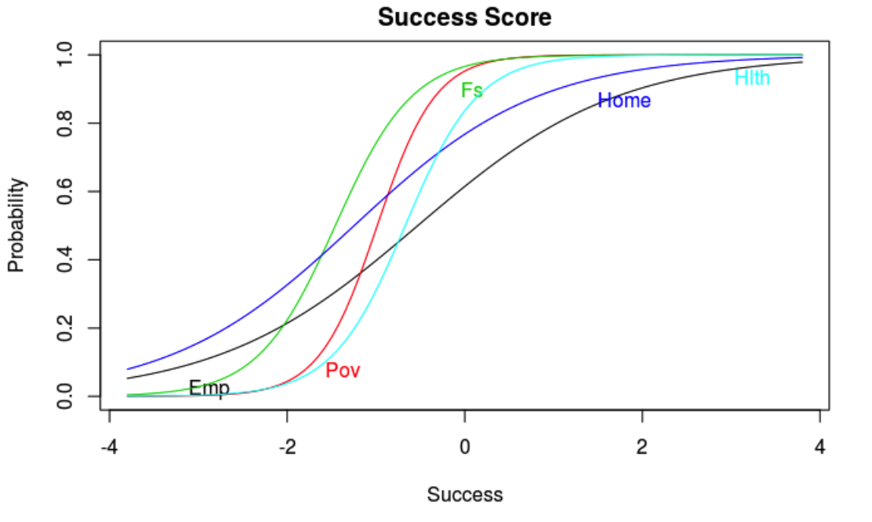

Figure 2: Item response curve for both immigrants and non-immigrants.

Two parameter model

Log Likelihood = -2308647

AIC = 4617313, BIC = 4617431

|  |  |  |  |
| --- | --- | --- | --- |
|  | Value | Std.Error | Z.vals |
| Difficult  Emp  Pov  Fs  Home  Hlth | -0.53  -1.00  -0.69  -1.29  -0.68 | 0.0032  0.0022  0.0190  0.0032  0.0020 | -165.0611  -456.4563  -461.7037  -262.2372  -348.3904 |
| Discrimination  Emp  Pov  Fs  Home  Hlth | -1.29  -0.68  0.88  0.94  2.42 | 0.0049  0.0020  0.0037  0.0039  0.0105 | 239.8742  195.5491  238.1937  238.3776  230.1665 |

Table 2: Item response parameters for both immigrants and non-immigrants

Non-immigrants are experiencing more success than immigrants. When the success score is positive, non-immigrants have higher success scores than non-immigrants. However, if the success score is below -0.5, immigrants are clearly the larger group (Figure 7). These observations are also demonstrated in Figure 8.

When we compare the two populations (Figure 3), we can see that immigrants have to worry more about owning a home and being employed, as they are harder to attain. This is not to say that other variables are not harder to achieve because figure 3 tells us that the lack of steepness in the hlth curve of the immigrant population compared to the migrant population, suggests that it is harder for them to achieve. This coincides with the statement by the migration policy, that in 2016 approximately 56 percent of immigrants in the United States had private health insurance (compared to 70 percent of the U.S. born), and 30 percent had public health insurance coverage (compared to 36 percent of the native born). About 20 percent were uninsured, compared to 7 percent of the U.S. born.[7] Not only that, the lack of steepness in their curves tells us that it is harder for the immigrant population to attain the level of success defined previously compared to non-immigrant population. Overall, this shows that there is a significantly larger difference in success scores between immigrants and non-immigrants.

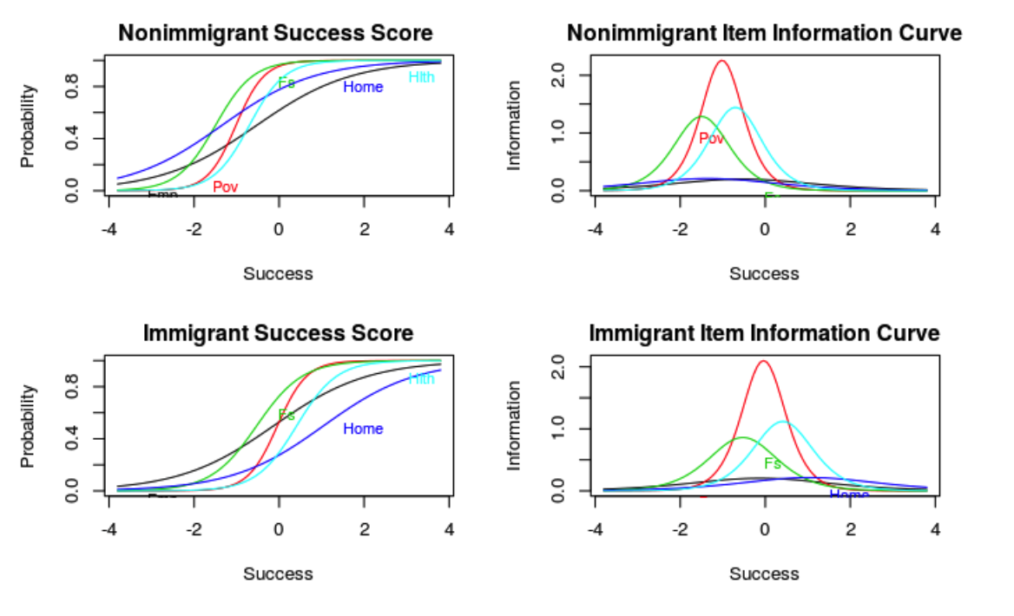

Figure 3: Item response for success score for both immigrants and non-immigrants

Two parameter model

Log Likelihood = -35897.99

AIC = 71815.99, BIC = 71890.03

|  |  |  |  |
| --- | --- | --- | --- |
|  | Value | Std.Error | Z.vals |
| Difficult  Emp  Pov  Fs  Home  Hlth | -0.1  -0.1  -0.69  0.99  0.39 | 0.0256  0.0130  0.0190  0.0329  0.0163 | -4.1934  -7.7498  -36.4401  30.2114  24.4854 |
| Discrimination  Emp  Pov  Fs  Home  Hlth | 0.82  3.25  1.88  1.03  2.00 | 0.0292  0.1522  0.0600  0.0353  0.0680 | 28.0694  20.7325  31.4424  29.4179  29.5031 |

Table 3: Item response parameters for immigrants

Two parameter model

Log Likelihood = -2265886

AIC = 4531792, BIC = 4531910

|  |  |  |  |
| --- | --- | --- | --- |
|  | Value | Std.Error | Z.vals |
| Difficult  Emp  Pov  Fs  Home  Hlth | -0.5342  -1.0172  -1.4982  -1.3511  -0.7015 | 0.0032  0.0022  0.0033  0.0053  0.0020 | -165.2653  -454.4247  -456.1290.  -256.5698  -349.6562 |
| Discrimination  Emp  Pov  Fs  Home  Hlth | 0.89  3.00  2.27  0.91  2.40 | 0.0038  0.0155  0.0097  0.0040  0.0106 | 237.7920  193.6244  234.9003  231.8934  227.2686 |

Table 4: Item response parameters for non-immigrants

**Final Model**

Our model summary shows that non-immigrants have significantly higher success scores than immigrants by an estimated 0.4324 after we take into account the effect of family size, marital status, sex, labor force, total income, and family movement on the success score (Table 2). This is a very large increase considering that the highest success score is 0.55 and the lowest is -1.5. We can also see that if a person is in the labor force, the estimated success score increases by 0.4662.

|  |  |  |  |  |  |
| --- | --- | --- | --- | --- | --- |
| Variable | Estimate | Variable | Estimate | Variable | Estimate |
| Intercept | -.7316 | Divorced | -.3632 | Nonimmigrant (binary) | .4324 |
| Family Size | -.07079 | Widowed | -.2468 | Total income | .000004430 |
| Single, never married | -.2059 | Abroad (past year) | -.2947 | Labor force (binary) | .4662 |
| Married, spouse absent | -.2003 | Moved between states (past year) | -.1625 | Female | .1459 |
| Separated | -.4567 | Moved within state (past year) | -.1537 |  |  |

Table 5: Final Model Variable estimates for measuring success

**DISCUSSION**

We see that the arrival of immigrants does not mean higher crime rates, and in fact this section shows that immigrants are not measuring up to the same level of success as non immigrants. Instead of focusing on the supposedly crime committing stereotypes of immigrants, it is important for legislators to shift their focus on equifying opportunities to both immigrants and non-immigrants. For instance, although since the implementation of the Affordable Care Act in 2014, health insurance coverage has improved for both immigrants and the U.S. born[8], our results suggest that this coverage is still unreachable to some immigrants.

**CLUSTER COMPARISON ANALYSIS OF SOCIO-ECONOMIC STANDINGS OF IMMIGRANTS**

From the previous analysis, we found that immigrants do not experience the same success level as nonimmigrants. In fact, when we group the states by features such as political affiliation, white percentage, and other demographics, we can see more clearly the disparity between living conditions of immigrants and nonimmigrants. By clustering states and comparing immigrants by these clusters, we can show that there is a large polarization for immigrants in privileged states.

K-means clustering was used to make three clusters of 51 states in the United States based on four variables: political affiliation (Pew Research Center), the Christian percentage in a state (Pews Research Center), unemployment rate (United States Census) , and the percent of White population in a state (United States Census).

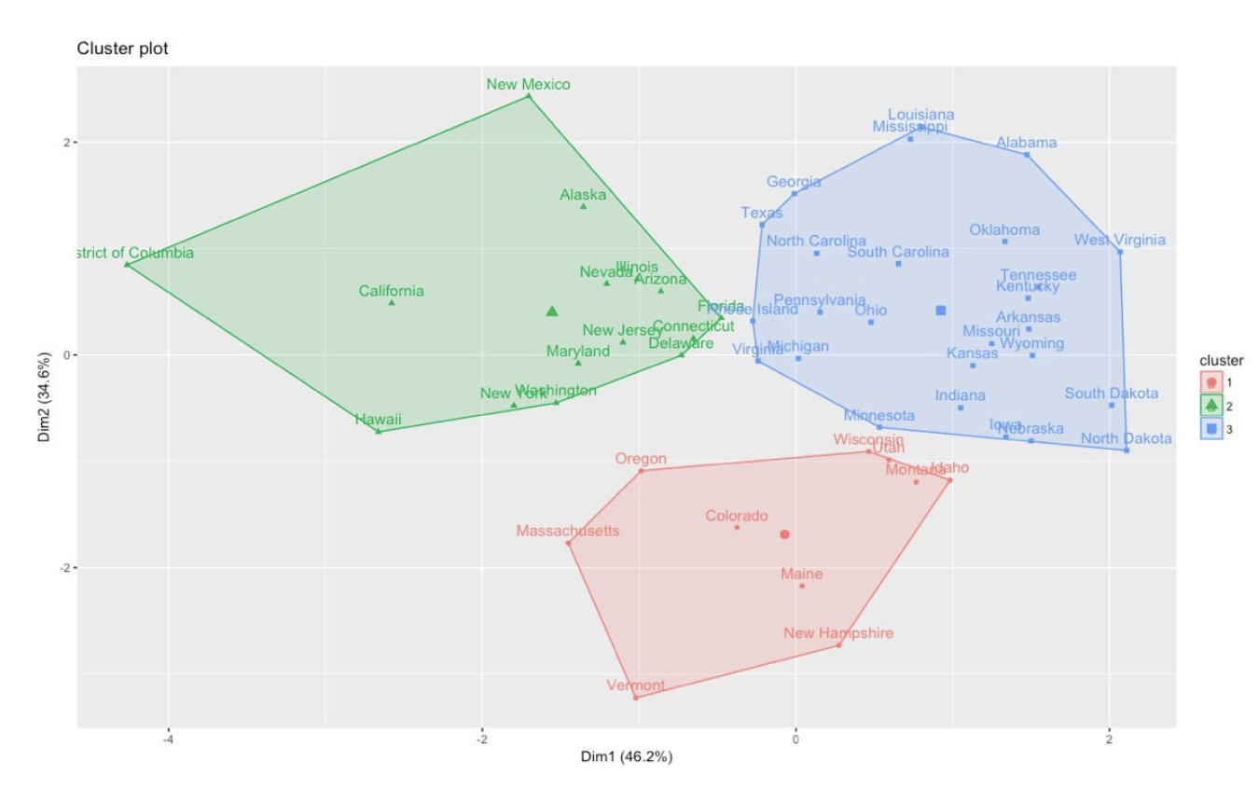

Figure 4: Three clusters by k-means clustering

Shared features by clusters were examined and identified below:

1. Cluster 1: Predominantly white, liberal, rich states (mostly New England states)
2. Cluster 2: Diverse population, blue states, and less rich states
3. Cluster 3: (Mostly) poor and predominantly white states (mostly Southern states)

**Cluster comparison**

Within state cluster information, 359,542 immigrants from the eight travel ban countries, who immigrated to the United States during 2005-2016 as reported by Censuses (IPUMS USA), were assigned to a cluster number. This cluster number was created by the preceding state cluster analysis (Figure 4), based on their state residency. By doing cluster comparison analysis, we can find clusters of immigrants that relate and compare these different clusters. Variables that indicate an immigrant’s socioeconomic standing were used to compare immigrants by clusters.

**Demography of immigrants**

*Birthplace*

The largest proportion of immigrants in cluster 1 are from Iraq (0.443) and Iran (0.316). Similarly, a large proportion of immigrants from cluster 2 is from Iraq (0.370) and Iran (0.292). However, the large proportion of immigrants from cluster 3 is from Iraq (0.279) and Egypt (0.245). Overall, the largest proportion of immigrants is from Iraq, where cluster 3 has the most even ratio, compared to cluster 1 and cluster 2.

*Age*

The mean age of immigrants among three clusters are similar (cluster 1=30.9 years, cluster 2=31.4 years, cluster 3=29.1 years), with cluster 2 having the highest mean. The mean of age for all clusters is 30.2 years.

**Total Family Income**

The total family income reports the total pre­tax money income earned by one's family. Immigrants from cluster 2 have the highest total family income among three clusters (without log function: cluster 1=$26,226, cluster 2=$44,175, cluster 3=$33,411, and all clusters= $34,604). This means that immigrants living in diverse population, blue states, and less rich states have the highest total family income among three clusters.

**Employment Status**

Employment status indicates whether the respondent was a part of the labor force. A large proportion of immigrants from cluster 1 is unemployed, and cluster 2 and cluster 3 have the similar unemployment ratio (cluster 1=0.638, cluster 2=0.574, cluster 3=0.573). Thus, immigrants living in predominantly white, liberal, rich states have the highest unemployment rate among three clusters.

**Food Stamp Recipients**

Food stamp recipients indicates whether anyone in the household receives Food Stamps. The largest proportion of people who receive food stamps is from cluster 1, and cluster 2 and cluster 3 have the similar ratio. Therefore, immigrants living in predominantly white, liberal, rich states has the highest ratio of receiving Food Stamp among three clusters (cluster 1=0.631, cluster 2=0.452, cluster 3=0.447).

**Means of Transportation**

Means of transportation reports the respondent's primary means of transportation to work over the course of the previous week. The largest proportion of immigrants who do not own a car are from cluster 1, whereas cluster 2 and cluster 3 have the similar ratio (cluster 1=0.753, cluster 2=0.686, cluster 3=0.650). So immigrants living in predominantly white, liberal, rich states have the highest ratio of not owning a car among three clusters.

**Inference**

We can conclude that immigrants from cluster 1 are less privileged than immigrants from other two clusters. Compared to cluster 2 and cluster 3, cluster 1 has higher ratio of immigrants who are unemployed, do not have a car, receive food stamps, and have the lowest mean of family income of all three clusters. For the demography of clusters, the highest proportion of immigrants in cluster 1 is from Iraq (0.443), Iran (0.316), and Somalia (0.129). Cluster 2 and cluster 3 tend to have similar trend except cluster 3 has more diverse birthplaces. Thus, immigrants living predominantly white, liberal, and rich states tend to be underprivileged. Because the cluster of underprivileged immigrants live in the cluster of more privileged states, the disparity of living conditions causes the polarization of immigrant cluster compared to non-immigrant cluster. This polarization issue may be one cause of the negative stereotype often shown in the media that immigrants are poor[9]. This could be a reason that immigrants have such a difficult time transitioning and adapting to life in the United States.

**Conclusion**

Our analysis supports that the narrative that immigrants bring tremendous crime and poverty into the United States is actually false. Increased immigrant arrival is associated with decreased violent crime rate over years. However, focus should be placed on the fact that immigrants experience less success than non immigrants. When state demographics are further examined, immigrants who live in richer states live under the higher poverty level and attain less success than they should, given that they are in more privileged states. It is especially urgent for predominantly white, rich New England states to have more programs that support immigrants’ well-being, since we observed a large polarization of living condition between the immigrant and non-immigrant population in this region. Moreover, rather than halt policies that stop immigration like President Trump did in January, supporting these policies may be a better solution[10]. Here are several ways the results from our analysis can be helpful:

* Advocate for revising and lifting the travel ban, because it is based on unfounded reasoning rather than empirical evidence
* Advocate for more immigration immersion programs to be created in order to help their integration process in the United States, especially in predominantly white, rich New England states
* Open more dialogue about immigrants and the travel ban, in order to raise awareness and debunk negative stereotypes against Muslim immigrants relating to violence and terrorism

**References**

Bennett, B. (2018). Trump wants to kill two immigration programs, but doesn’t seem to know

how they work. *Los Angeles Times.* Retrieved from: <http://www.latimes.com/politics/la-na-pol-trump-immigration-20180117-story.html>

Diepenbrock, G. (2016). Negative media portrayals drive perception of immigration policy, study

finds. *The University of Kansas*. Retrieved from: <https://news.ku.edu/2016/11/29/negative-media-portrayals-drive-perception-immigrants-study-finds>

Shannon, R. (2011). Breaking the Mould: Refugees, Stereotypes, and Canadian Media. Capstone

Seminar Series, Capital Issues: Missing Narratives from Canada’s National Capital (1), 1–18.

Syrian refugees battle stereotypes in fight to fit in. (2016, October 18). Retrieved from:

<https://www.washingtontimes.com/news/2016/oct/18/syrian-refugees-battle-stereotypes-in-fight-to-fit>

U.S. Department of Homeland Security. (2018). Immigration Data and Statistics, Definitions of

terms. Retrieved from: <https://www.dhs.gov/immigration-statistics/data-standards-and-definitions/definition-terms#permanent_resident_alien>

The White House. (2018). Executive Order Protecting the Nation from Foreign Terrorist Entry

into the United States. Retrieved from: <https://www.whitehouse.gov/presidential-actions/executive-order-protecting-nation-foreign-terrorist-entry-united-states/>

**Appendix: Data Tables and Figures**

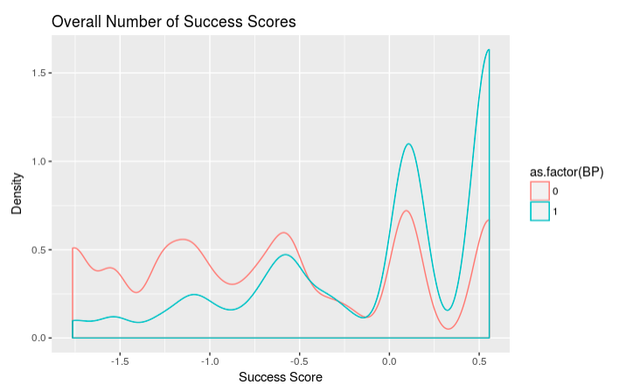

Figure 7: Density plot of success scores, differentiated by immigrants and nonimmigrants

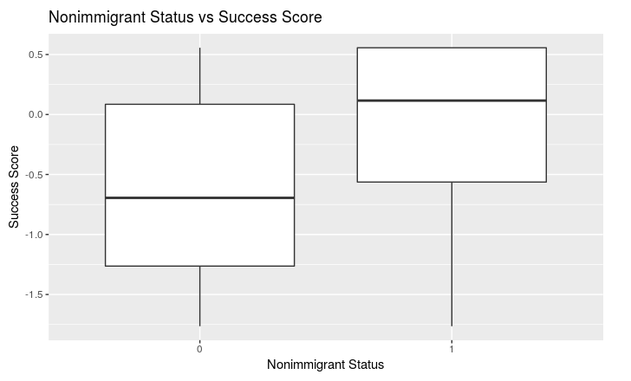

Figure 8: Boxplot showing the differences in success scores for immigrants and nonimmigrants

Figure 9: Birthplace of individuals by cluster comparison analysis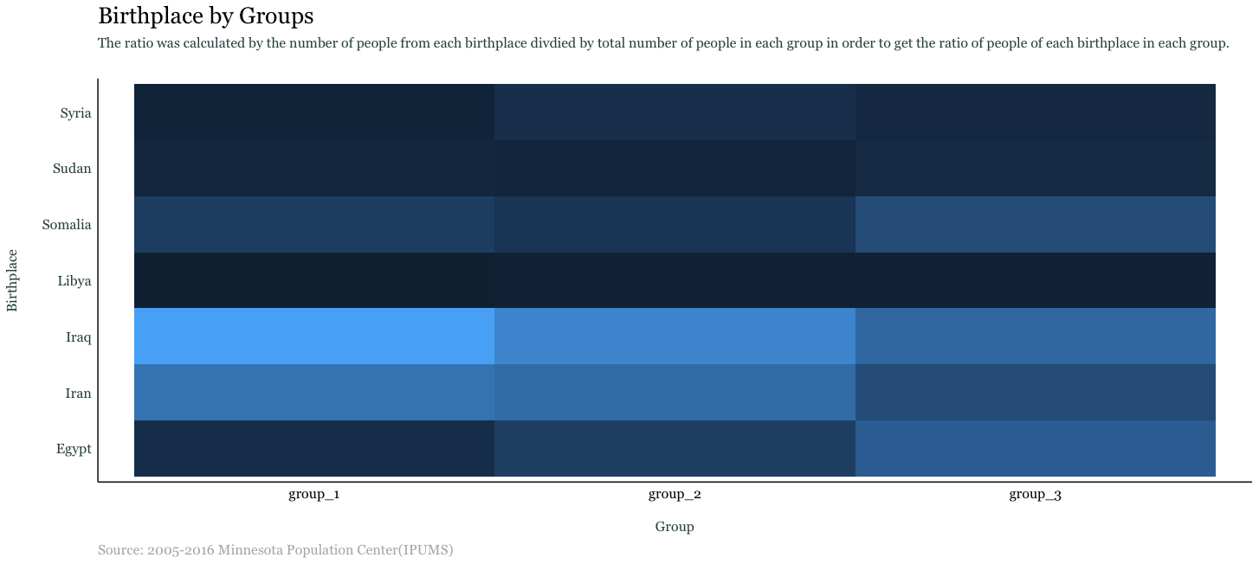

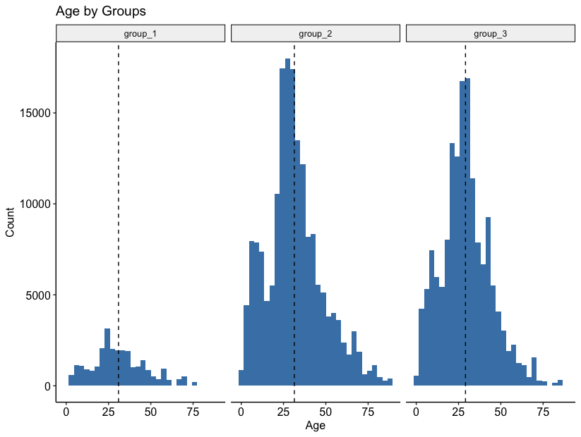

Figure 10: Age by cluster comparison analysis

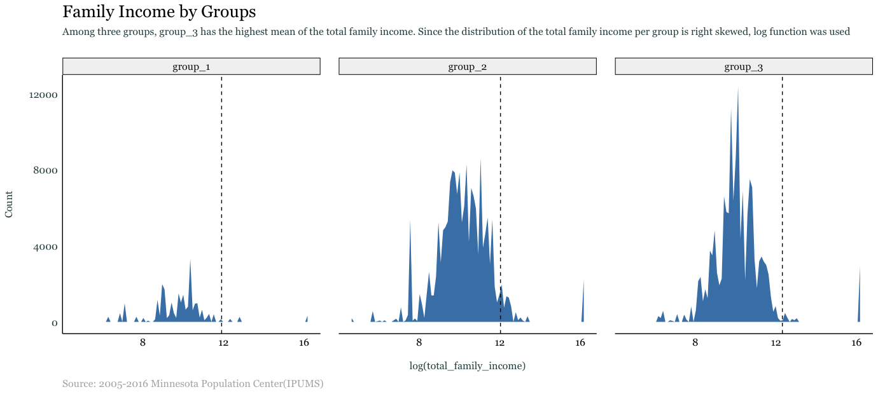

Figure 11:Total family income by cluster comparison analysis

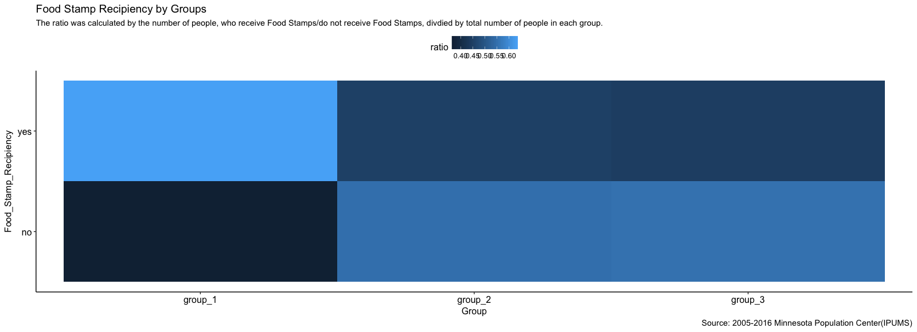

Figure 12: Food Stamps recipients by cluster comparison analysis

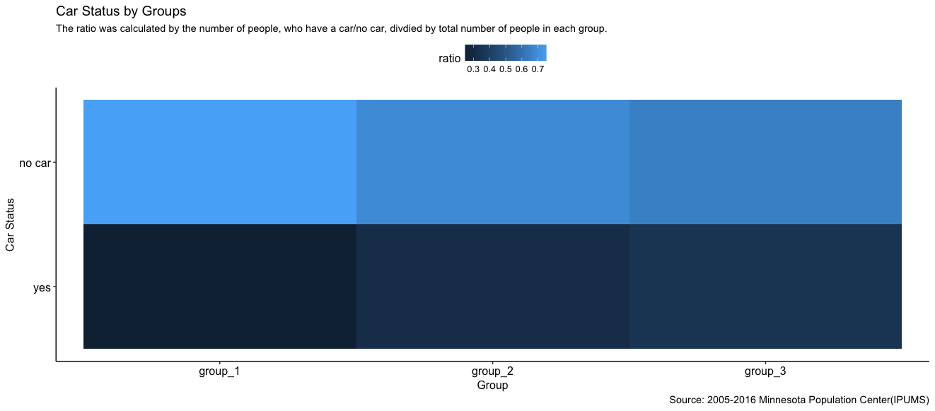

Figure 13: Possession of car by cluster comparison analysis

1. Executive Order Protecting the Nation from Foreign Terrorist Entry into the United States. (n.d.). Retrieved from https://www.whitehouse.gov/presidential-actions/executive-order-protecting-nation-foreign-terrorist-entry-united-states/
2. The Muslim-majority country Chad was not added in the travel ban by the time of this analysis
3. Definition of Terms. (2018, March 16). Retrieved from <https://www.dhs.gov/immigration-statistics/data-standards-and-definitions/definition-terms#permanent_resident_alien>
4. Shannon, R. (2011). Breaking the Mould: Refugees, Stereotypes, and Canadian Media. Capstone Seminar Series, Capital Issues: Missing Narratives from Canada’s National Capital (1), 1–18.
5. https://usa.ipums.org/usa/
6. https://usa.ipums.org/usa/
7. https://www.migrationpolicy.org/article/frequently-requested-statistics-immigrants-and-immigration-united-states#HealthInsurance
8. https://www.migrationpolicy.org/news/latest-top-stats-immigration-united-states-published-annual-data-rich-article
9. Negative media portrayals drive perception of immigration policy, study finds. (2016, December 06). Retrieved from https://news.ku.edu/2016/11/29/negative-media-portrayals-drive-perception-immigrants-study-finds
10. Bennett, B. (2018, January 17). Trump wants to kill two immigration programs, but doesn't seem to know how they work. Retrieved from http://www.latimes.com/politics/la-na-pol-trump-immigration-20180117-story.html